**Nicholas Reggi Personal Portfolio**

Group 7

Nicholas Reggi – n9738525

**Artefact 1** – Data Flow Diagram

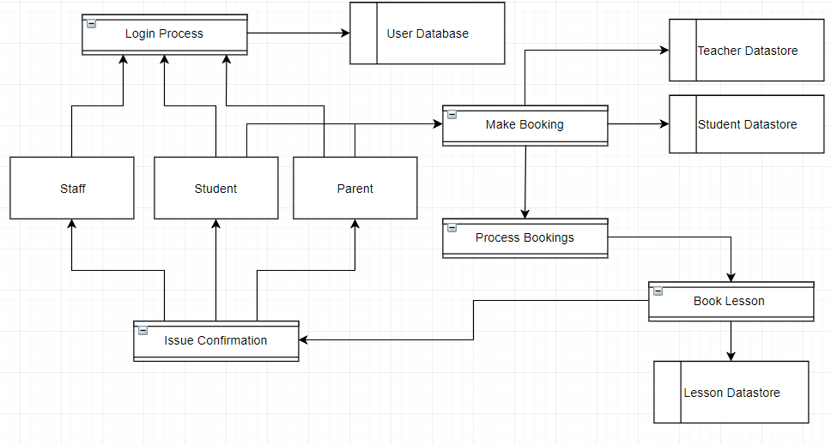The data flow diagram below graphically represents the flow of data through the information system, modelling its process aspects of the music school. This analysis was provided to the Development team members for them to analyse it and take it into consideration when they are developing the back-end systems.

The data flow diagram above depicts the information process flow when one of the stakeholders uses the website. All parties use the login process to gain authorisation into the system, the information that is stored in the user database. A student or parent can make a booking which then store this information in the Teacher and Student Datastore. The process of ‘make booking’ then moves into the process of ‘process bookings’. Once the booking is processed the lesson is booked aka ‘book lesson. This information is stored in the Lesson Datastore. Once the lesson is booked a confirmation is sent to the Staff, Student and parent in the process of ‘issue confirmation’.

The use of the data flow diagram allows all parties of the team to easily see the data flow of the music schools website.

**Artefact 2** – Initial User Interface

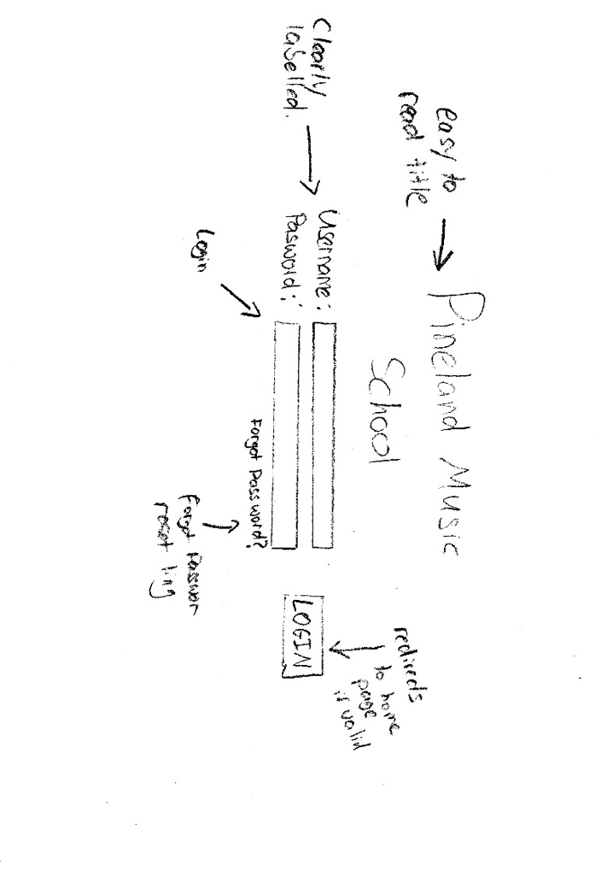A user interface design is a way to visual display how the website may look at its complete stages, and in this case, being the very initial thinking. This is a low fidelity design of the user interface but still effectively shows what the end goal is.

Login Screen:

* Focus’ on being easy to read and navigate
* Option for forgot password reset link
* Fields for user login.

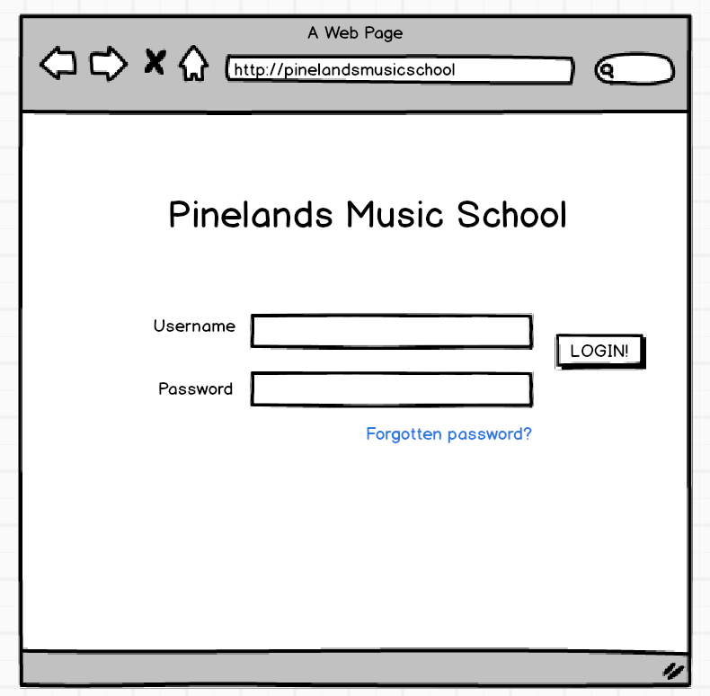

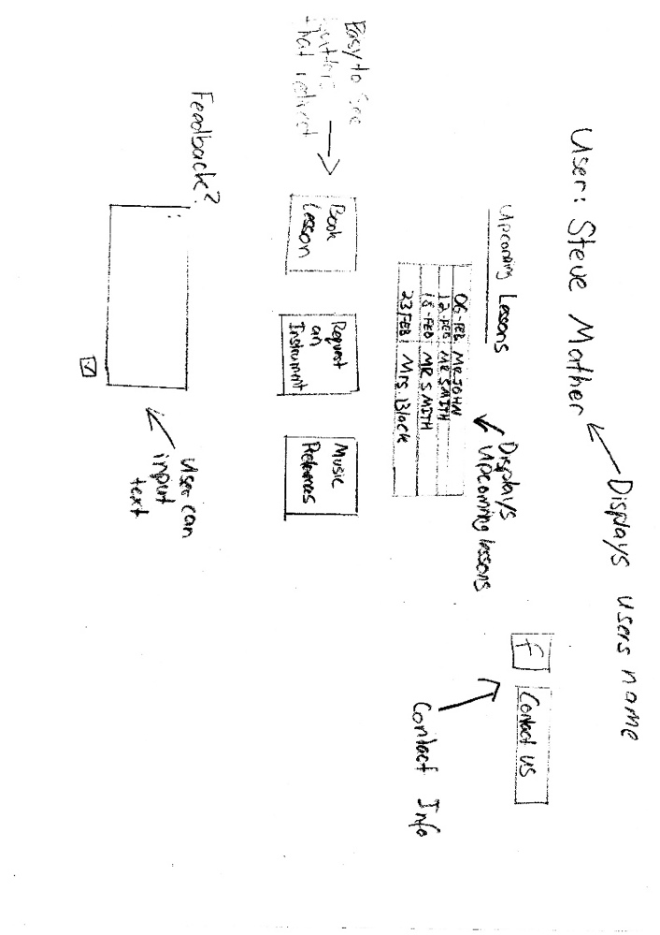Main Menu:

* Displays personalised information
* Upcoming Lessons section auto-updates for upcoming lessons (would be for teachers and students)
* Easy to navigate buttons in the middle of screen linking to other pages
* Feedback section below where users can give feedback.
* Contact us info easily accessible

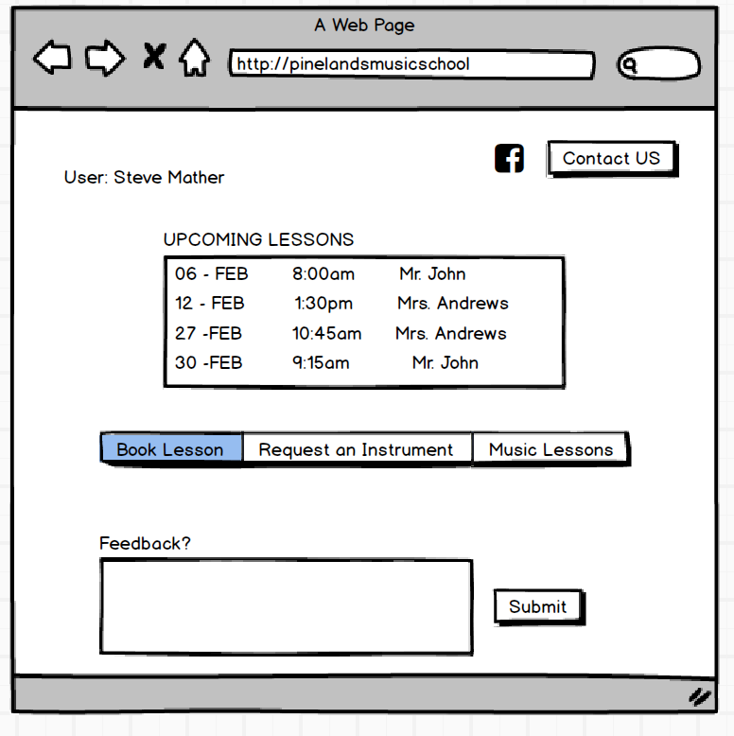

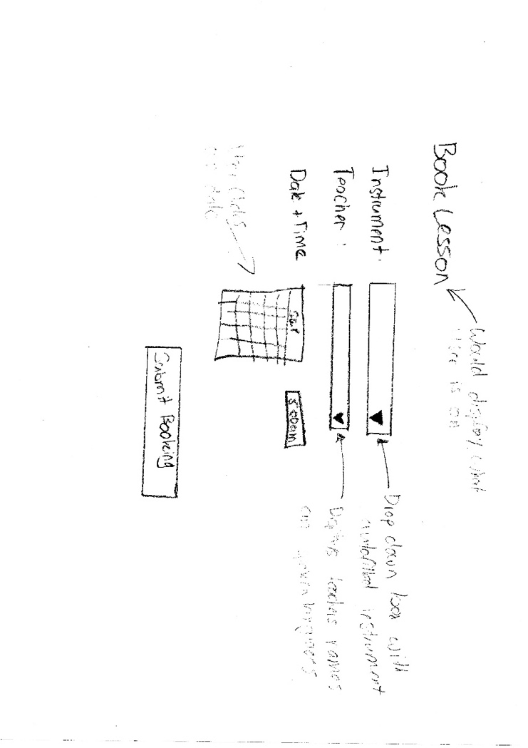Book Lesson:

* Clearly displays what page is for
* Instrument has drop down box which has instruments already prefilled in alphabetical order
* Teacher drop down will update according to instrument selected (vice versa)
* Date and time field – Includes calendar type input of date.
* 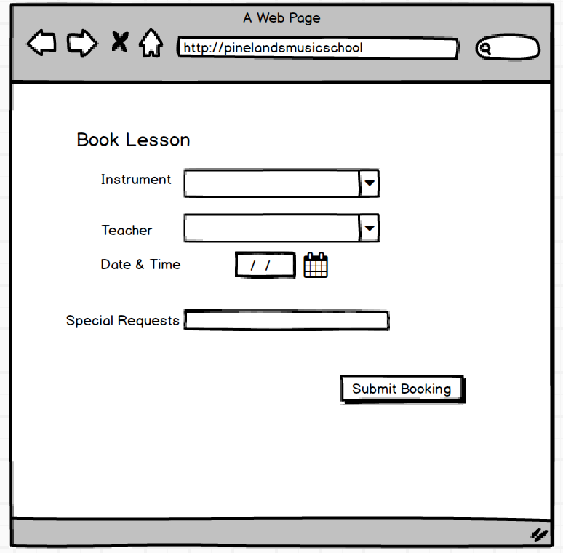Submit booking button which submits it for approval.

These initial user interface designs greatly benefited the thought process and ensured all parties involved were on the same consensus. These designs were open for criticism and feedback as it was essential user friendly

**Artefact 3** – Test Data

Test Data is the data that is used in the tests of the software system before all real data has been input. It is used to see how data is displayed, how the data flows, and to ensure the accuracy of the input data. This ensures that when real life data is used for the music school, that it will run the same way. The development team requested the data be input in excel so that they may refer to the data when the coding is complete.

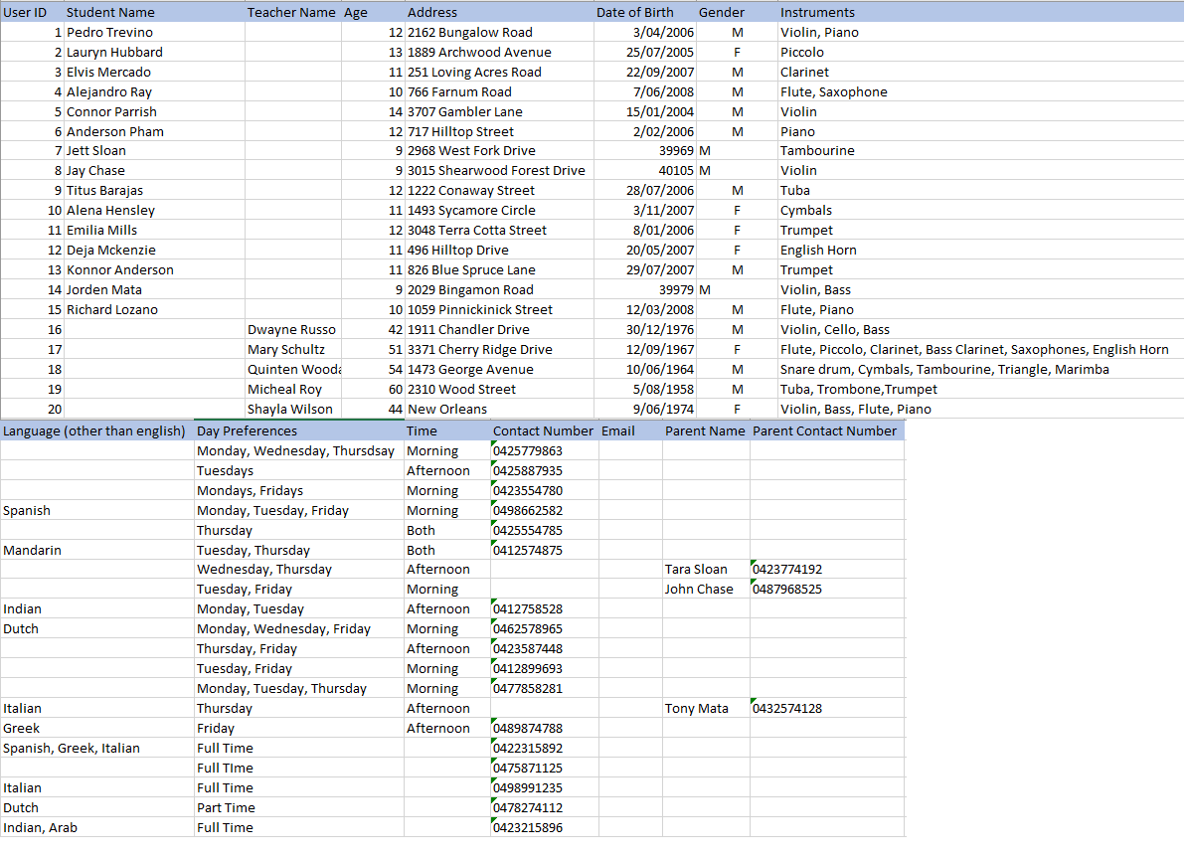

The test data above will be given to the development team for them to use and test with it during there production phase.

**Artefact 4** – Root Cause Analysis (Fishbone Diagram)

A fishbone diagram helps identify the root cause and effects of different aspects of a problem. It is a visualization tool for categorising potential causes of an issue, in order for the root cause to be identified.

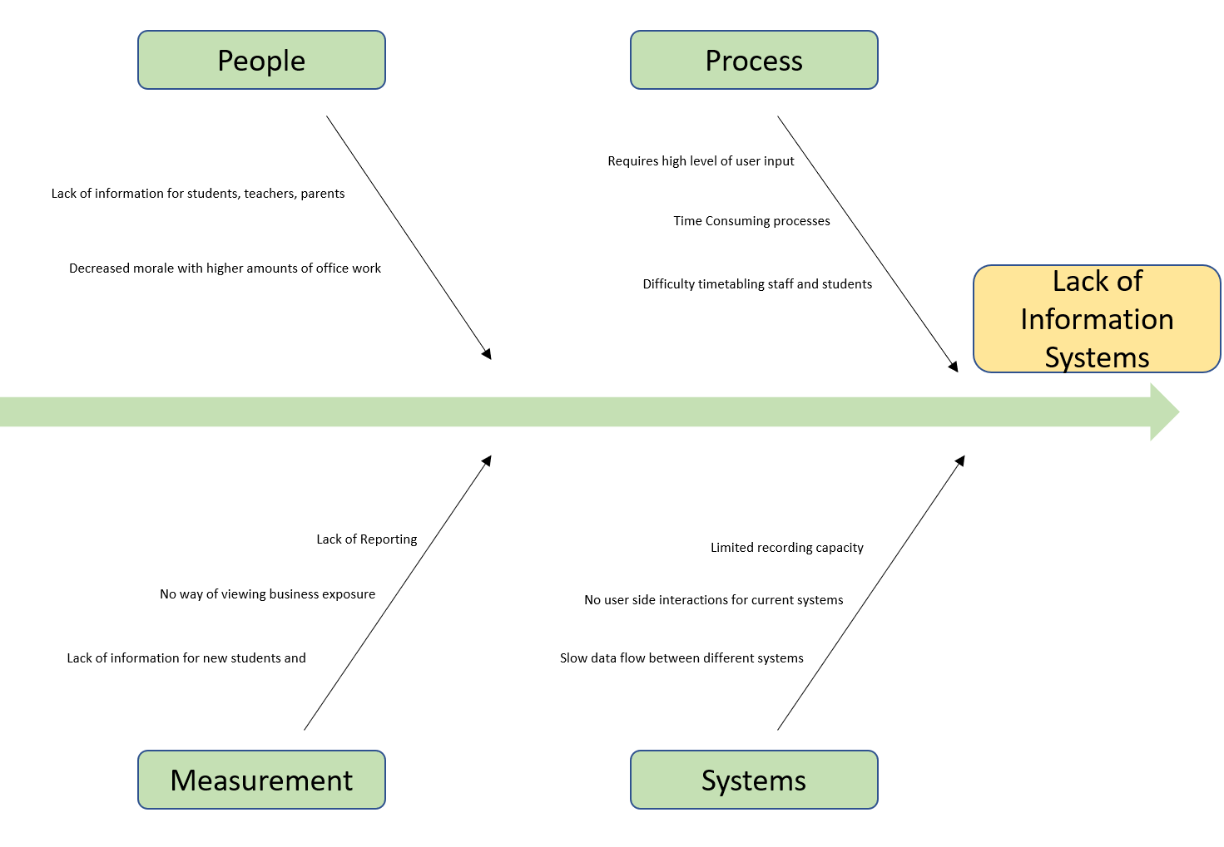

Conduct a root cause analysis through a Fishbone diagram improved the client and development teams understanding of the issue that is trying to be fixed. By implementing an information system (running the webpage and storing the data), it will help improve all the smaller issues which are currently making the business.

**Artefact 5** – Storyboarding

A storyboard is a graphical representation of a sequence of events with an outcome. In the case below, it depicts the client interaction with the system and shows the positive effect it can have. The use of storyboarding creates real life cases for the product and describes and accurately shows how a teacher may decide to use the system to their advantage.

